CSE 113 Homework 1

Report

Implementing Mutexes

8 Core | Bakery | Filter | cpp_mutex
Throughput | 485393 | 421760 | 1942950
Fairness | 0.86% | 3.86% | 5.27%
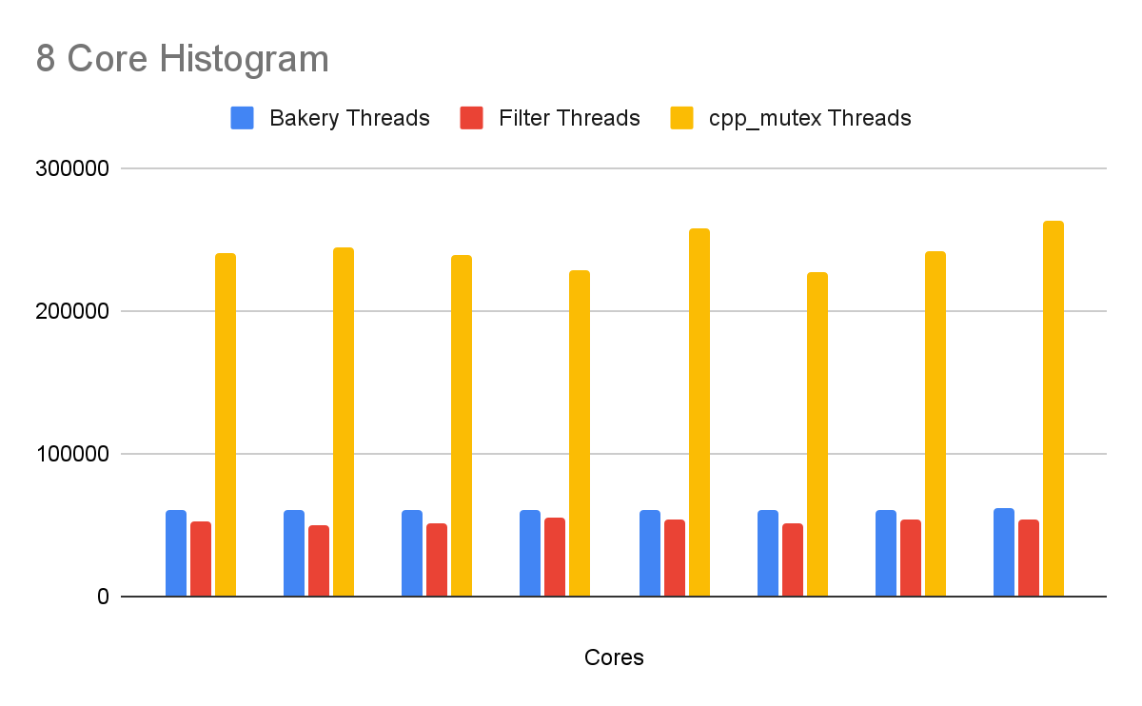

32 Core | Bakery | Filter | cpp_mutex
Throughput | 90630 | 61146 | 1927606
Fairness | 1.47% | 7.35% | 25.35%
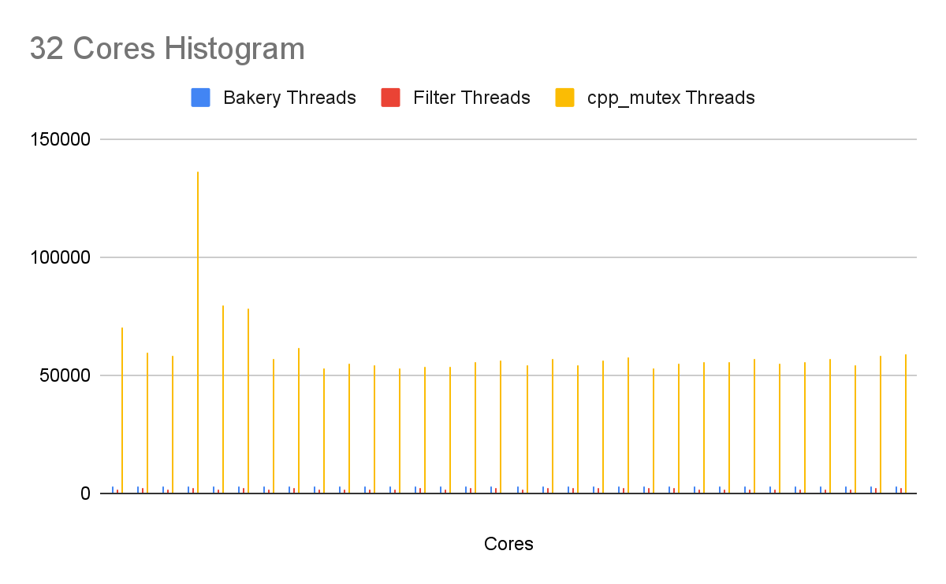

Server | Bakery | Filter | cpp_mutex
Throughput | 241796.8 | 104995.2 | 2485010
Fairness | 0.06% | 3.02% | 3.00%

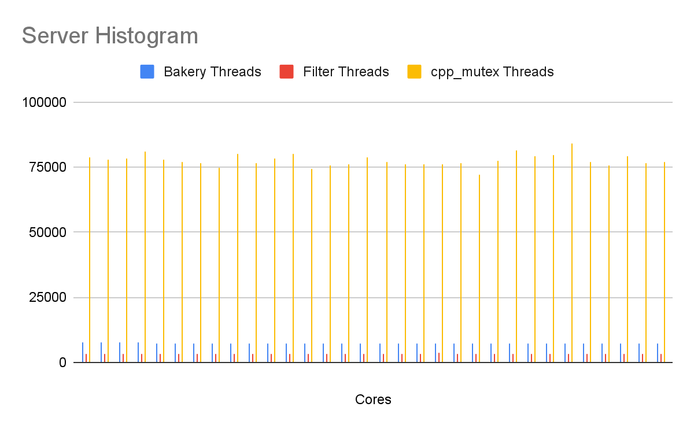
Something surprising from the results is that I didn’t expect to see mutexes have such a drastic reduction in throughput as compared to the cpp_mutex versions. It is almost looking like 10x as much as seen in the server as compared to local testing but it’s insane. I also saw the fairness value be more drastically different in the local testing rather than the server, with the cpp_mutex having a 25% CV which is just extreme. This is most likely due to one of the threads being a major outlier and removing them would create more fairness and create a more fair CV. The results below reflect the final implementation including the yield() optimization.
An overall analysis is that the bakery algorithm provides does a slightly better job than the regular lamport filter and has an overall higher throughput with a very low CV, however the cpp_mutex is capable of doing much faster operations however, I’m also sure that there were more hazards and conditions that weren’t being prevented as compared to the filters. The scheduler also just randomly allows any of the threads to acquire the lock and therefore, isn’t fair by default. The filters are very deliberate but much slower in execution and allows more precise numbers and data writes but will overall produce a much lower throughput as without the mutex.

A Fair Reader-Writer Lock

Fair_mutex | Readers | Writers
Local Throughput | 60809 | 117973
Server Throughput | 111757 | 276458
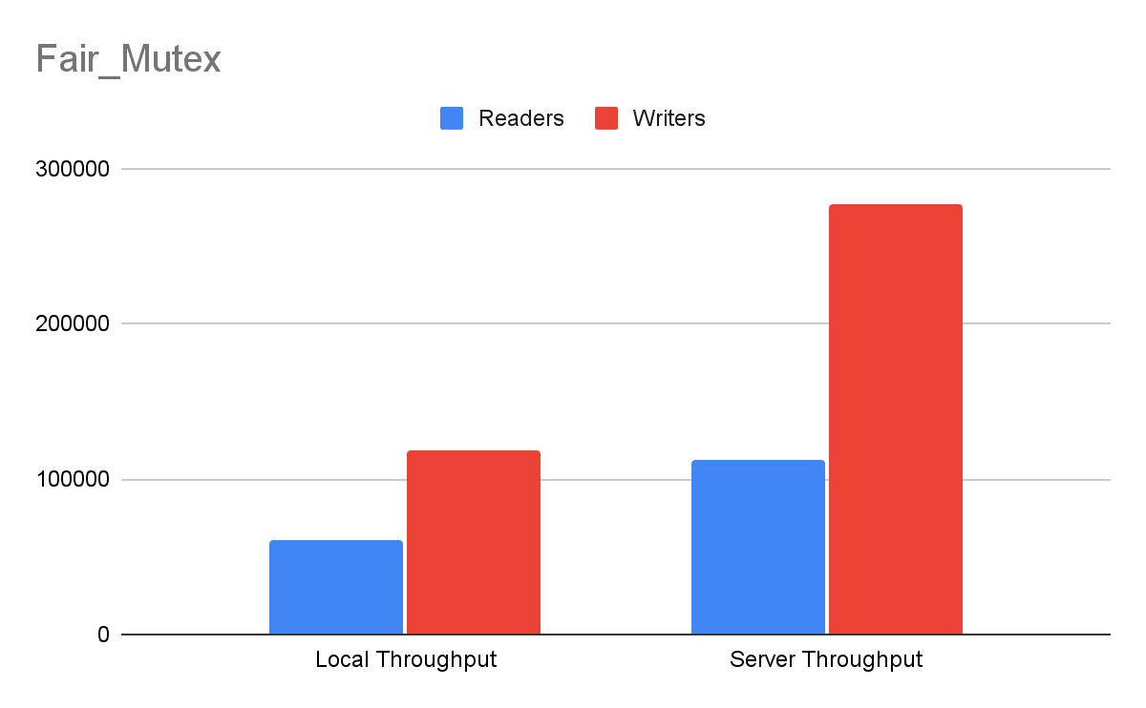

Default_mutex | Readers | Writers
Local Throughput | 789305 | 11134
Server Throughput | 1701451 | 22544
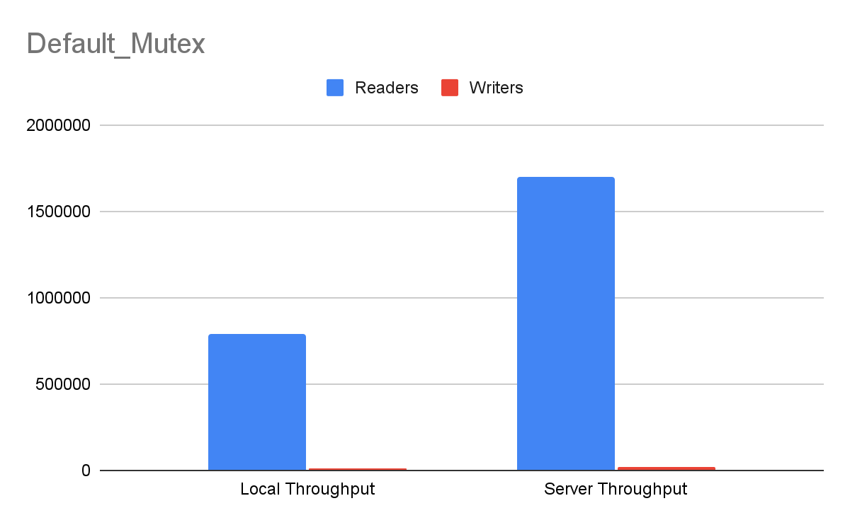
The solution to this was to just create a precedent to allow the writers to acquire the lock rather than just have it being passed in sequential order and that was done through taking advantage of the parameters surrounding the readers and writers locks. I made it so that if a writer wants to write, the readers wouldn’t acquire the lock and that way, it gives the writers the chance to acquire the locks first.
Something interesting in the data is that my implementation actually allowed the writers to write while the default_mutex shows that the writers were barely even allowed to write and that the readers would just pass their locks between each other, starving the writers indirectly. By creating these additional parameters to allow the writers to get a chance to actually make a change, the writers were actually able to acquire the locks more than the readers. Another thing was that the readers were not being starved and were able to actually acquire the lock as well.

A Concurrent Linked List

Part 3 | Coarse Lock (Local Avg) | Coarse Lock (Server) | RW Lock (Local Avg) | RW Lock (Server) | Swaptop (Local Avg) | Swaptop (Server)
Total Operations (Throughput) | 69909.67 | 838567 | 259672.67 | 2096609 | 234619 | 2398959
Total Pops | 9668.67 | 134530 | 271.67 | 412 | 203 | 324
Total Pushes | 11309.67 | 115565 | 268.67 | 406 | 276 | 296
Total Peeks | 48931.33 | 588472 | 259132.33 | 2095791 | 229583.33 | 2397625
Total Swaptops | 0 | 0 | 0 | 0 | 4556.67 | 714
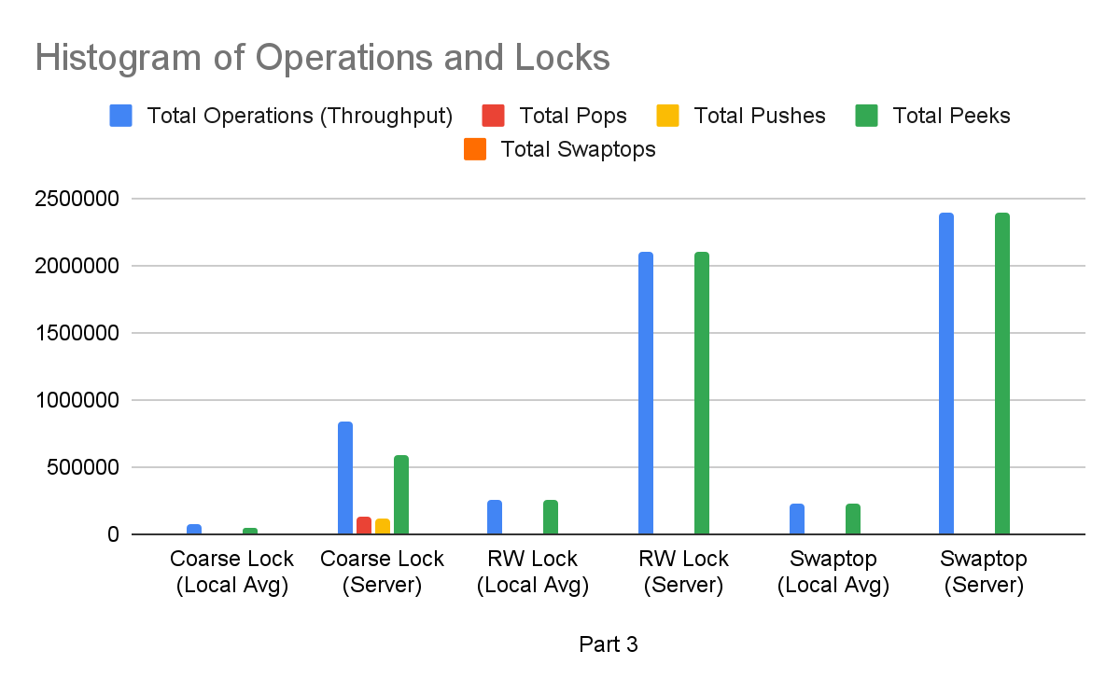
The solution to swaptop was to split it between two parts to optimize function. We first have to check the null case, if the values are the same, in situations where we don’t need to even perform the swap. Therefore, we would acquire that shared lock and ensure that a swap needs to happen. If it doesn’t, we return the lock and make no changes, if a swap needs to occur, we then relinquish that read lock, acquire the write lock, and then swap the top value using generic pointers and give it that required value and then relinquish the writer lock.
Across the 3 trial runs, the throughput remained relatively consistent, suggesting the locking overhead is deterministic. The results are quite shocking in that I didn’t expect the peeks and total operations to fluctuate so much as compared to the prior experiments. The server was able to perform much more operations, and specifically, peeks too a major priority, potentially showcasing a starvation occurring. However, the RW locks allow much more peeks to occur and much more throughput in operations. The Swaptop is quite similar to the RW Lock, but we could see that it’s still being performed, it’s just that the peeks took precedence of the locks and did many operations.
We could see though that the readers weren’t also being blocked/stopped by the writers as we could see with the coarse lock and RW Lock comparisons. The RW locks were able to perform MUCH more operations and allow the readers to thrive in their operations while the writers such as the pops and pushes may have had lower operations due to just not requiring them as much as the readers. I’m not sure how many readers were meant to happen so I cannot say if it was starvation or if it just allows the readers to perform as many reads without writer intervention, causing a major influx of peeks as compared to the pops and pushes.

Design Document

Implementing Mutexes

My thought process was to stick to the book, and use the algorithms in there as well as what I know to write the code. It was mostly just translating what I was seeing into what I had to use and therefore, I didn’t struggle too much with this part. The biggest issue was actually implementing that locking design using the atomicity library, however I just can translate what I didn’t know using what I learned from the slides into solving this problem. The images I used to solve this problem were below. The hardest part of this was actually just adjusting the variables and getting the initialization portions to work as well as the pointer logic, however that was just programming and I just needed to spend more time on it.

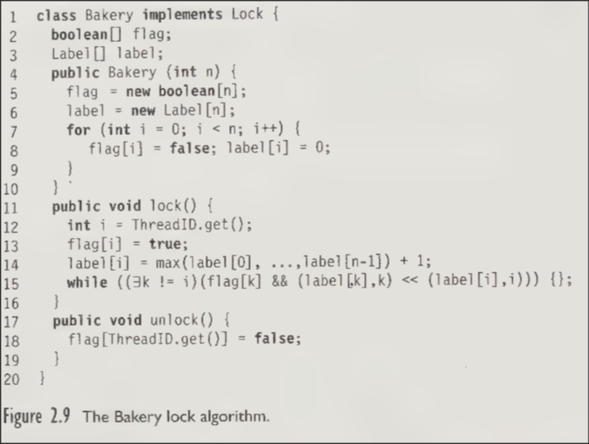
Image N: Bakery Algorithm
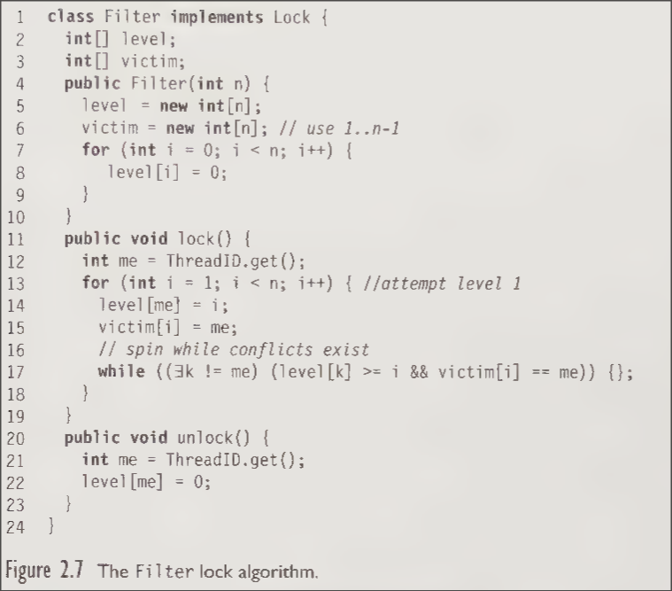
Image N: Filter Lock Algorithm

Implementing the yield took me a second since I just needed to brush up on what yield does and how it would help with the filter. Once I understood that it was just to optimize the locking portion once the thread is over and save time, it made it obvious to implement into the locking scheme.

A Fair Reader-Writer Lock

I was able to implement the Fair Reader-Writer lock knowing what I’ve learned from CSE 130, systems programming in which we dealt with thread spools and reader-writer locks. I created this system where it could prioritize writers and would essentially “yield” in its spinning locking design if any writers were to want to write. Beyond that, it was just implementing a way to track the active writers and if they wanted to write or not to then allow the readers to finish what they are doing but also give their locks up to the writers ASAP. This allowed that priority in which writers can write more and won’t be stopped by readers. This was my central design which came from the idea of a consumer and producer in which a consumer shouldn’t consume something if nothing has been produced, so creating these conditions to prevent the readers from reading if the writer wants to write is the main theory that needed to be implemented. Beyond this, I just built on top of what was given which was the default_mutex.h file.

A Concurrent Linked List

This one was like three mini assignments in which each one required the mutexes to be implemented in different ways. The first way, coarse-grain locking, required me to implement basic mutexes after each required moment such as allowing a pop, push, and peek to get the lock and unlock before it returns. This was similar to how we did it in CSE 130 so I was familiar with this. The rw_lock_stack.h was the same thing we did in coarse-grain locking, however I just needed to adjust the shared_mutex and the shared_lock onto peek. Lastly, the swaptop is the same implementation as the rw_lock_stack but just adds the swaptop function in which I first check if the data is already the same or null or any edge case to check if we need to even implement a swapping, using a shared mutex in the beginning and unlocking it after we conclude that a swap needs to be done. Then we do a regular mutex lock to swap that data and then unlock it at the end. Each part of the assignment built off each other and it was fairly direct and I didn’t need to blueprint much more than just adding that mutex and following the logic that we must acquire the lock to prevent any data conflicts and unlock it before we return it.

